LAB INSTRUCTION GUIDE
Deploying a Flask ML Application to Azure App Service
Method: Zip Deploy via Azure CLI

Objective | Deploy a Python Flask machine-learning application to Azure App Service using the Zip Deploy method.
Deployment Method | Zip Deploy (Azure CLI)
Estimated Duration | 30–45 minutes
Prerequisites | Azure CLI installed and authenticated (az login); an active Azure subscription; a working Flask application with requirements.txt.

Procedure
Complete the following steps in order. Each step includes the exact command to run, along with its purpose and any relevant notes.

1. Create a Resource Group
Command:
az group create --name SandhyaRG --location centralindia
- Purpose: A resource group is a container that holds your app and all related Azure services.
- Note: Choose a location close to your users, e.g. centralindia or eastus.

2. Create an App Service Plan
Command:
az appservice plan create --name SandhyaPlan \
--resource-group SandhyaRG --sku B1 --is-linux
- B1 — Basic pricing tier; low cost and suitable for testing.
- --is-linux — required for Python applications.

3. Create the Web App
Command:
az webapp create --name SandhyaVOISAI95 \
--resource-group SandhyaRG --plan SandhyaPlan \
--runtime "PYTHON:3.14"
- Purpose: Provisions the App Service instance where the Flask application will run.

4. Prepare the Code for Deployment
- Navigate to the project root directory: ML-with-UI_azure
Command (PowerShell):
Compress-Archive -Path app.py, requirements.txt, templates, static, local_model.pkl -DestinationPath app.zip -Force
- Ensure the ZIP archive contains the following:
  - app.py
  - requirements.txt
  - templates/
  - static/
  - local_model.pkl

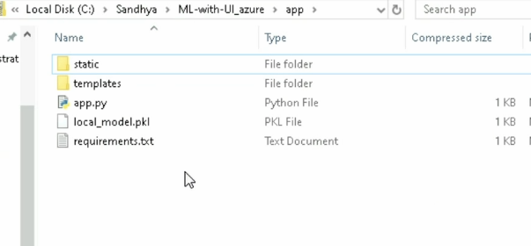

Enable Build Automation
Command:
az webapp config appsettings set --resource-group SandhyaRG \
--name SandhyaVOISAI95 \
--settings SCM_DO_BUILD_DURING_DEPLOYMENT=true
- Purpose: Ensures Azure automatically installs dependencies listed in requirements.txt.

Configure the Startup Command
- In the Azure Portal, navigate to: App Service → Configuration → General Settings.
- Set the Startup Command field to:
gunicorn --bind=0.0.0.0 --timeout 600 app:app
- Purpose: Starts the Flask application using Gunicorn, a production-grade WSGI server.

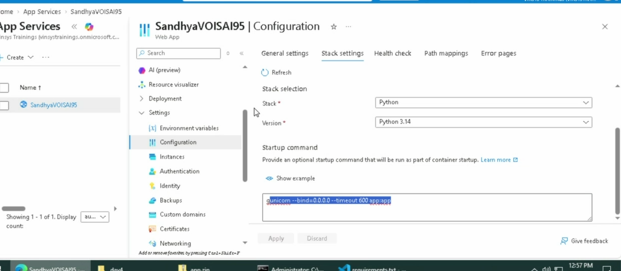

5. Deploy the ZIP Package
Command:
az webapp deploy --resource-group SandhyaRG \
--name SandhyaVOISAI95 --src-path app.zip --type zip
- Purpose: Uploads the application code and files to Azure App Service.

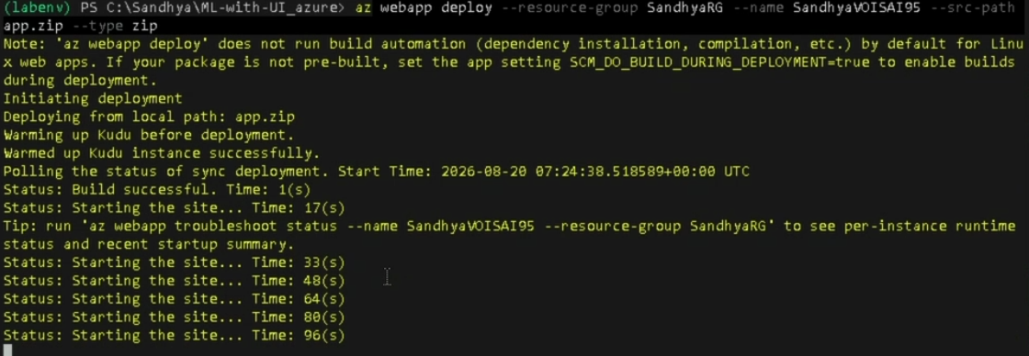

6.

7. Verify the Deployment
- Open the Kudu console to inspect deployed files:
https://SandhyaVOISAI95.scm.azurewebsites.net
- Confirm that project files are present under /home/site/wwwroot.
- Open the live application in a browser:
https://SandhyaVOISAI95.azurewebsites.net

Summary
Upon completion of these eight steps, the Flask ML application is deployed to Azure App Service using the Zip Deploy method. Application dependencies are installed automatically from requirements.txt, and Gunicorn serves the application in a production environment.

End of Document

